**DAY-03**

**11/10/2021**

**Name**: Harshal Acharya

**Roll No**: 12

**Batch**: B11

**Datasets:** covid_19_data

**Dimensions:**

* Country
* Last Update
* Observation Date

**Measures:**

* Confirmed
* Deaths
* Recovered
* S.No.

**Datasets:** Amazing Mart

**Topics:**

* Create Hierarchy of dimensions
* Revise Filter and calculated fields
* Create Scatter Plots
* Create Dashboards
* Add Interactive Action-Filters
* Add Interactive Action-Highlights

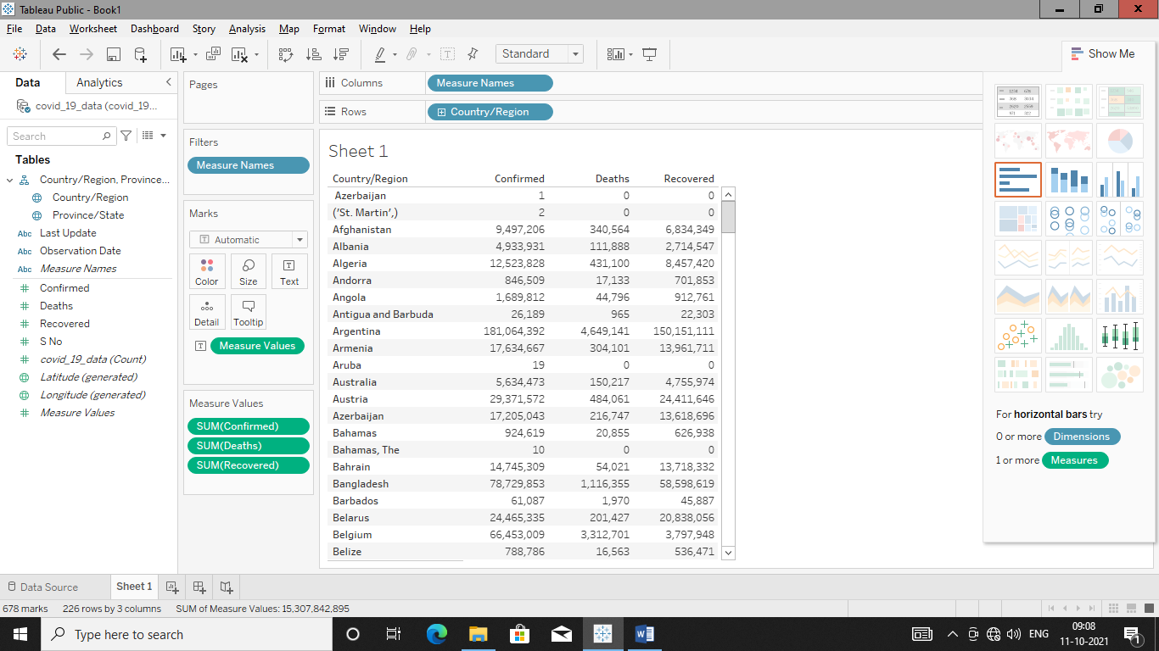

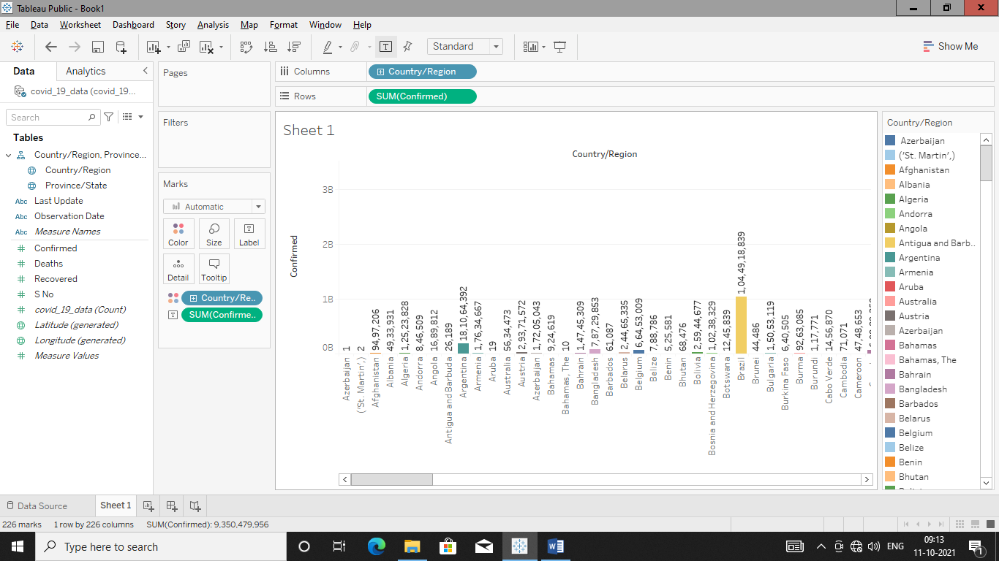

**Nationwise Confirmed,Recovered & Deaths**

Confirmed

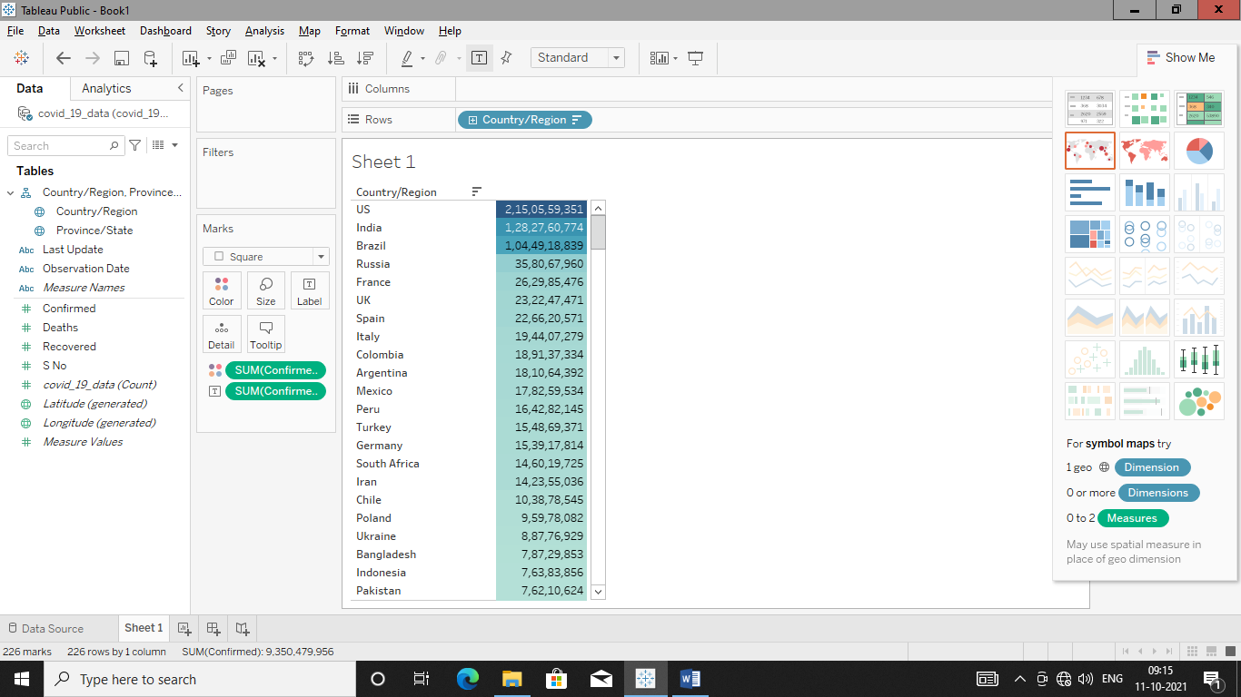

Deaths

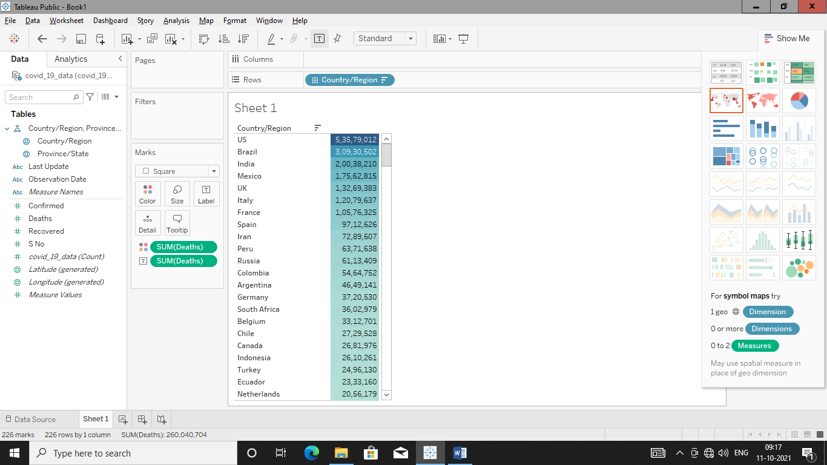

Recovered

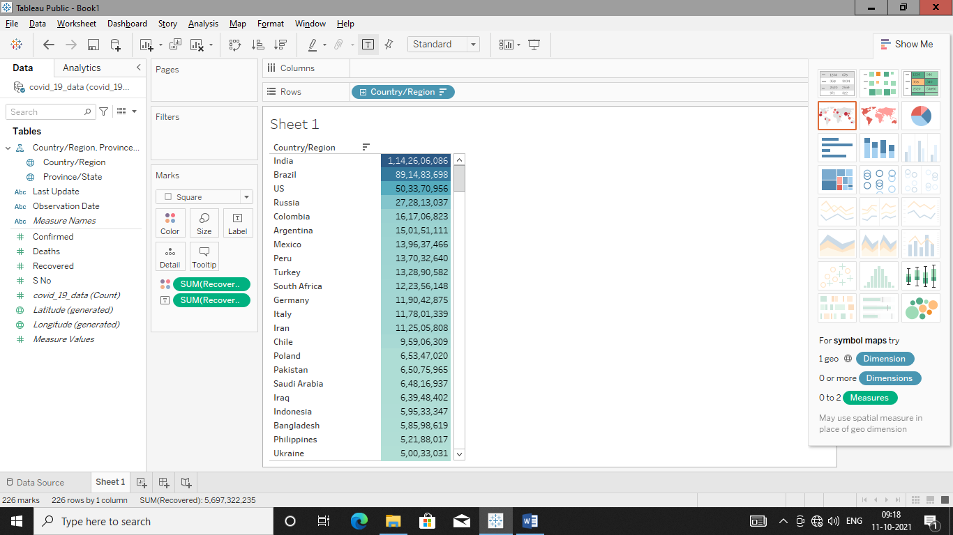

**Indian Statewise Confirmed,Recovered & Deaths**

**Highlight table**

Confirmed

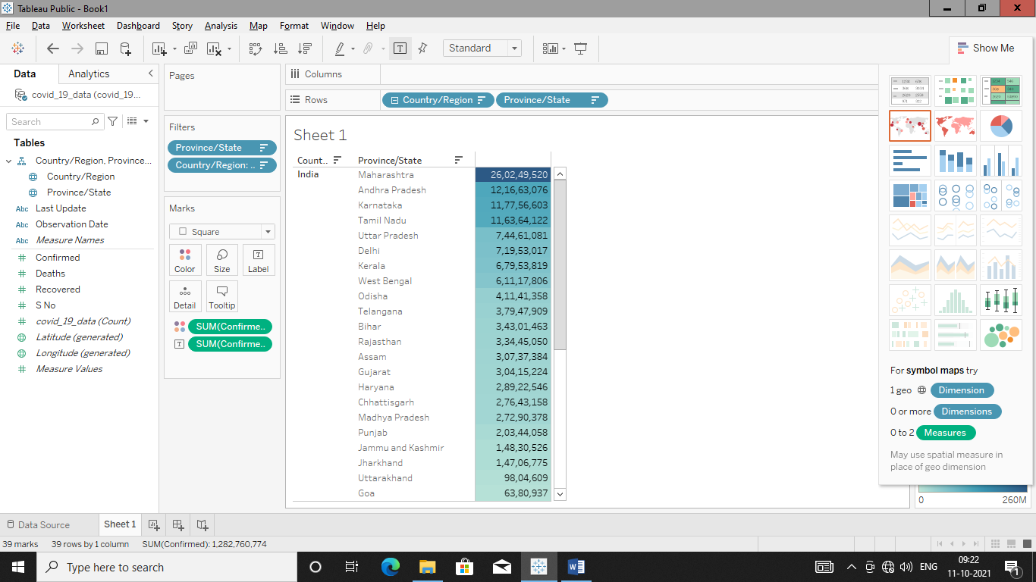

Deaths

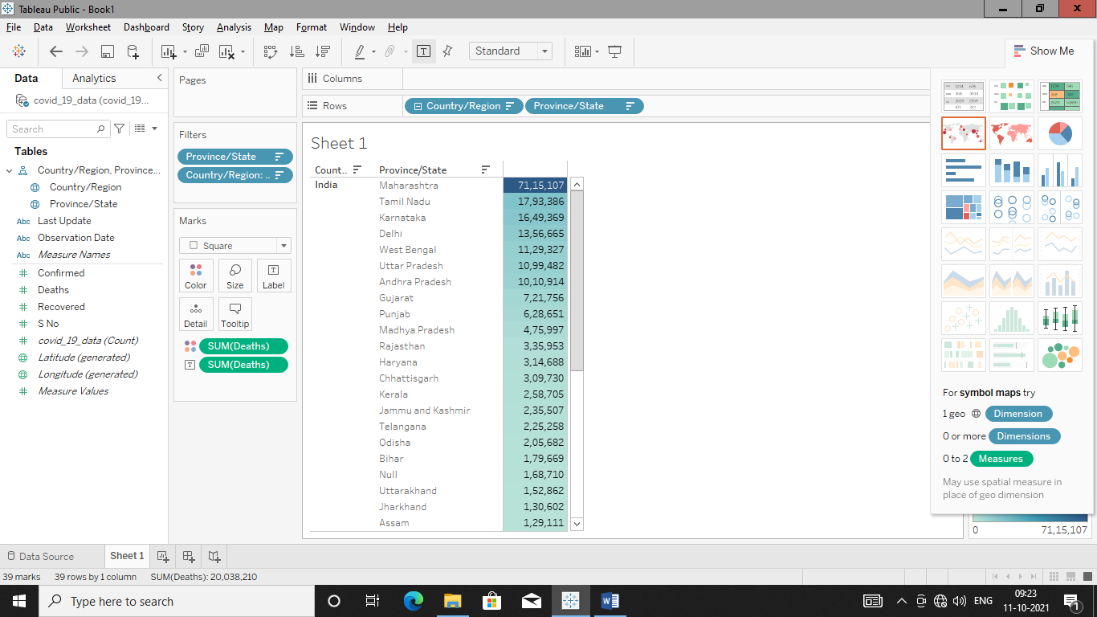

Recovered

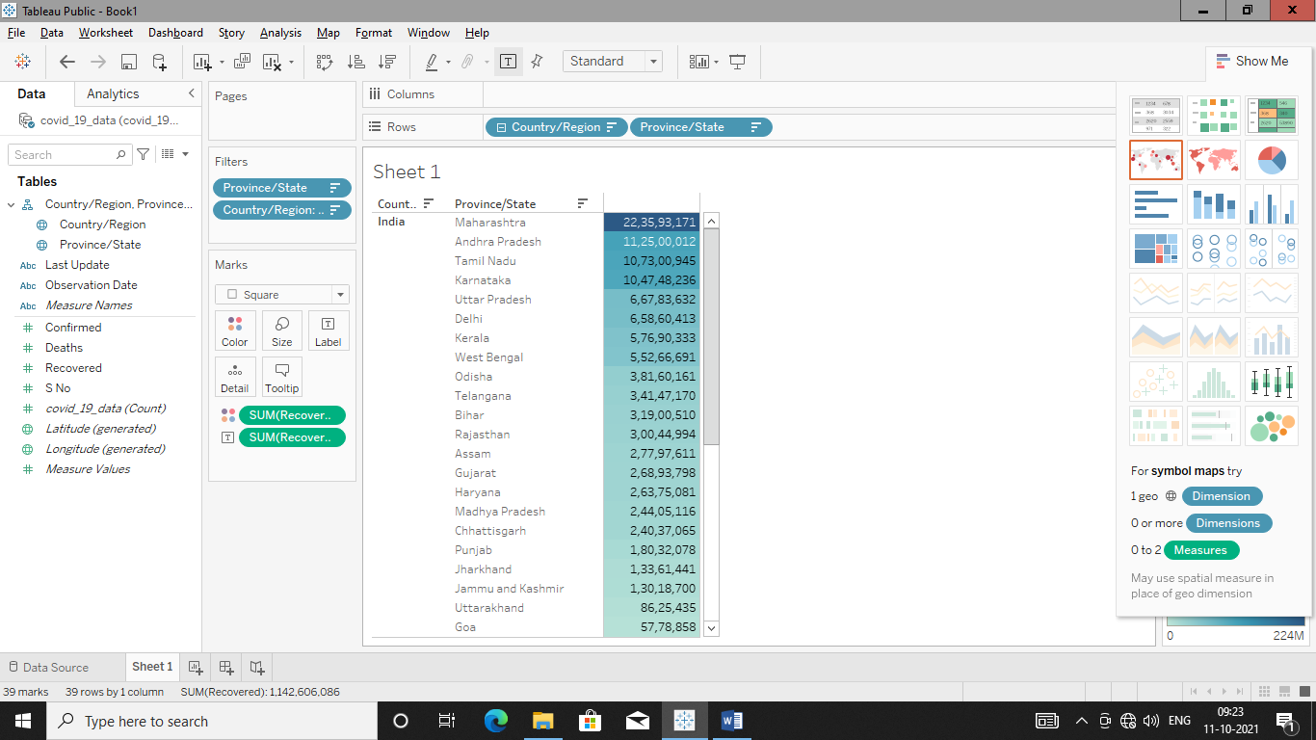

**Stack Bar with label & color formatting**

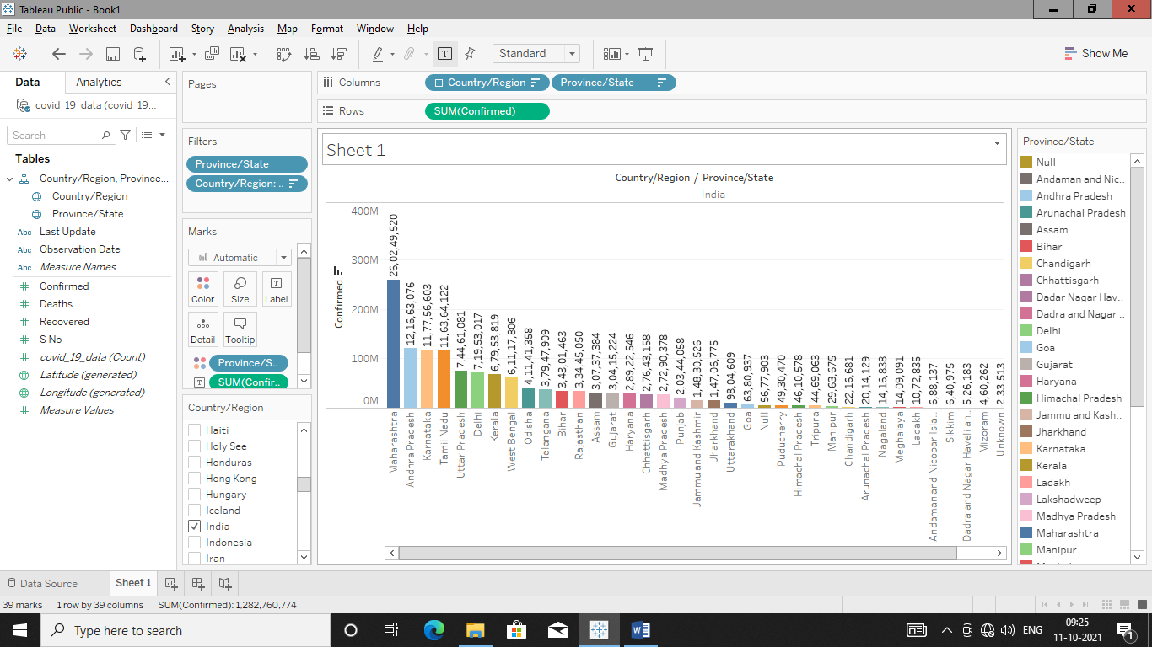

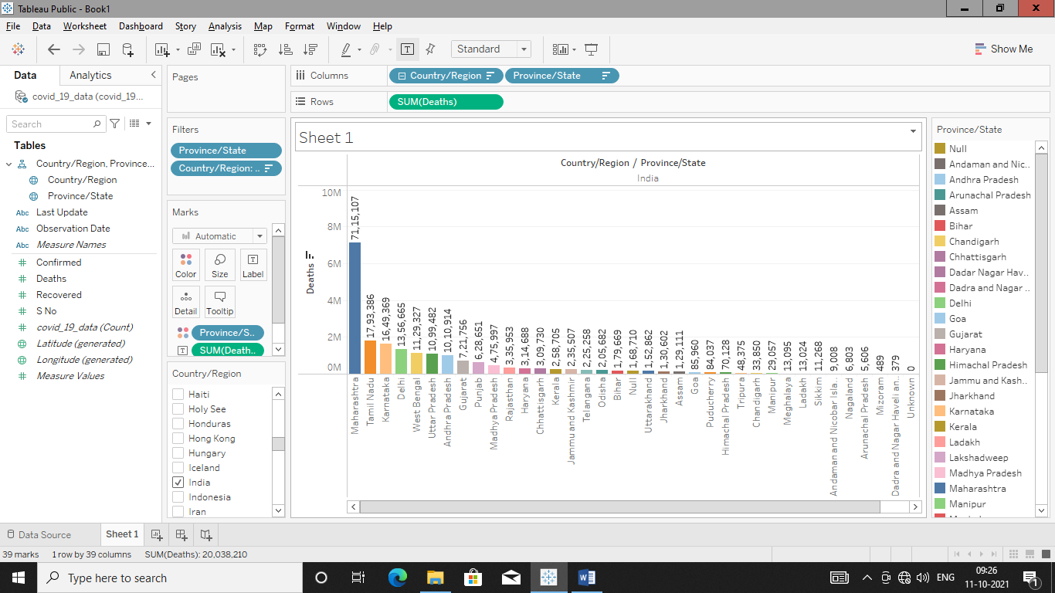

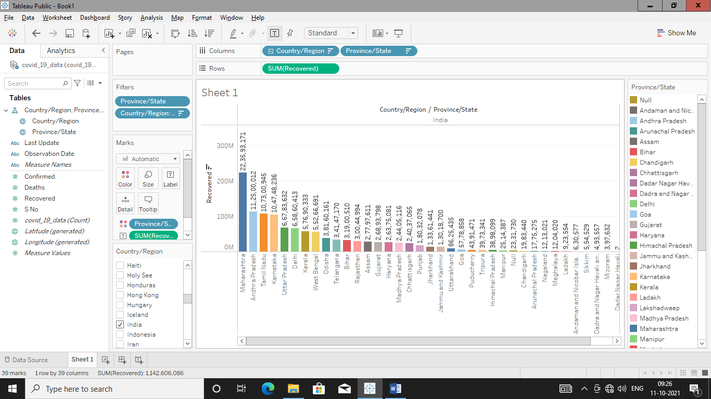

**Pie Charts For Confirmed,Recovered,Deaths**

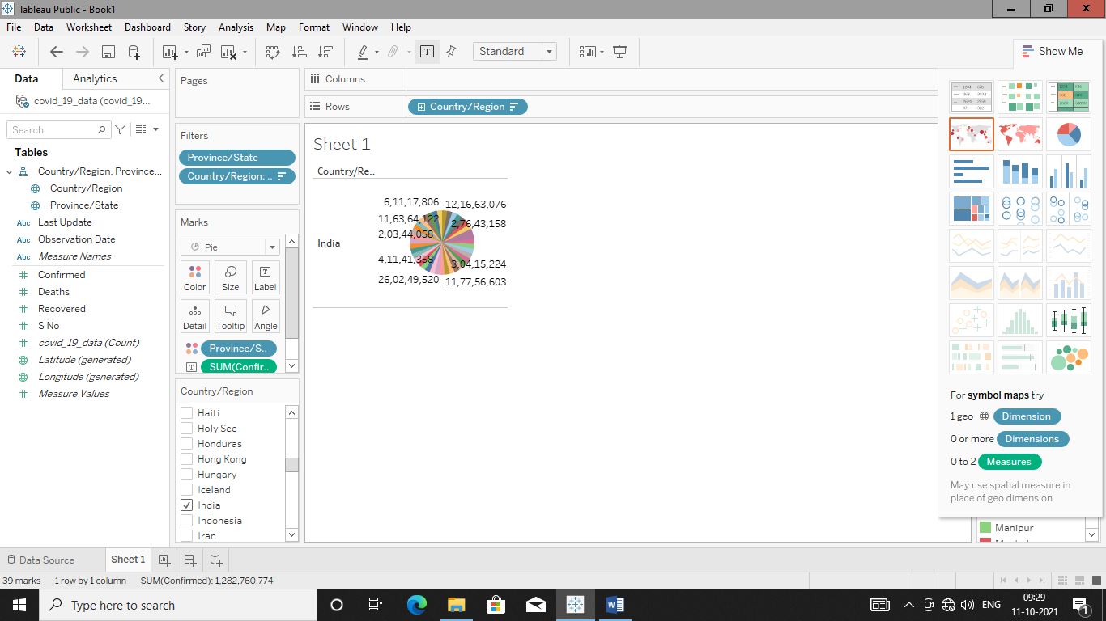

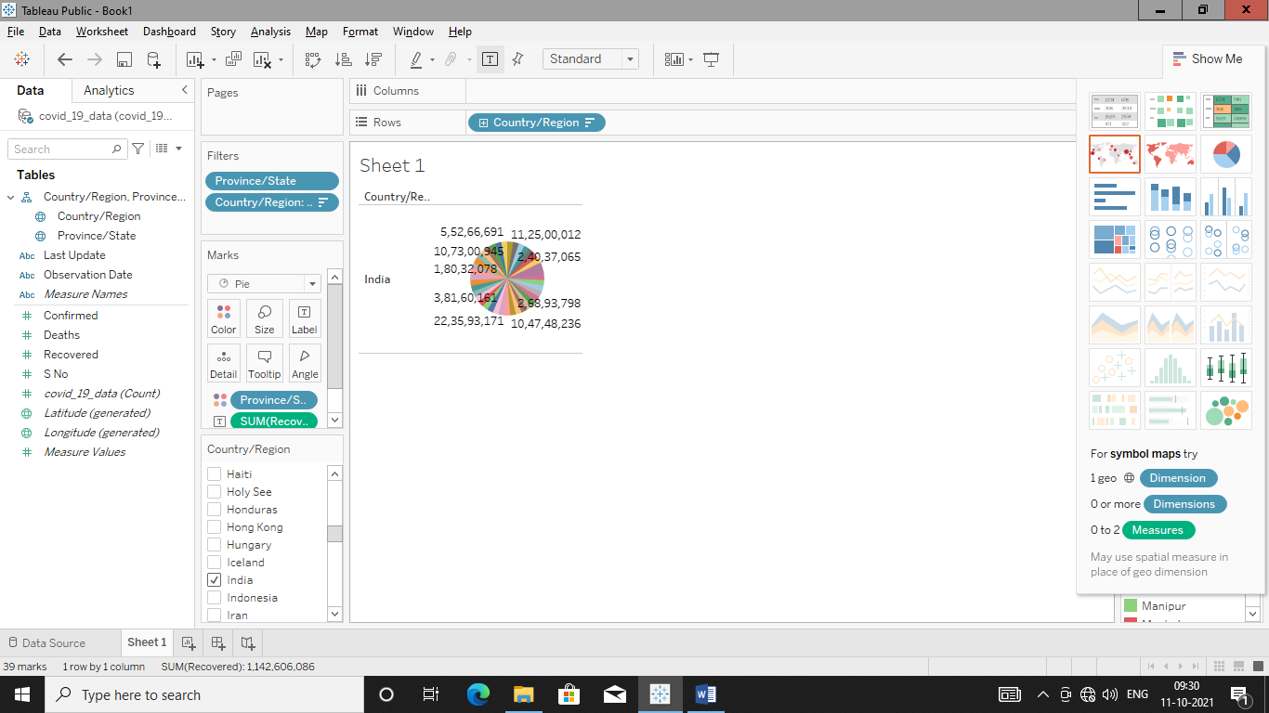

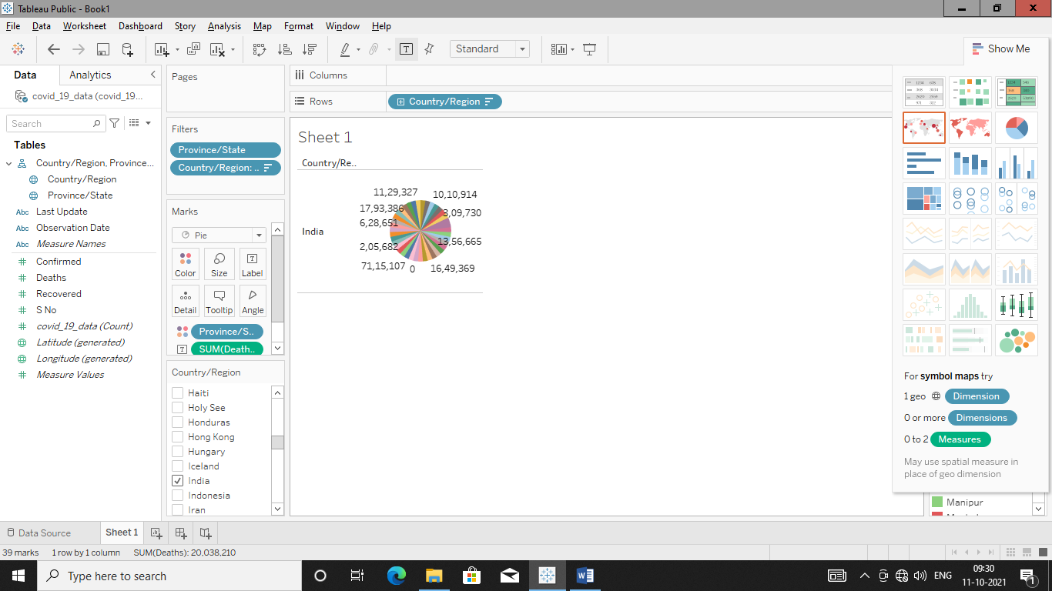

**Create hierarchy of dimension manually**

Here two tables from dataset is joined at logical level to create a hierarchy.

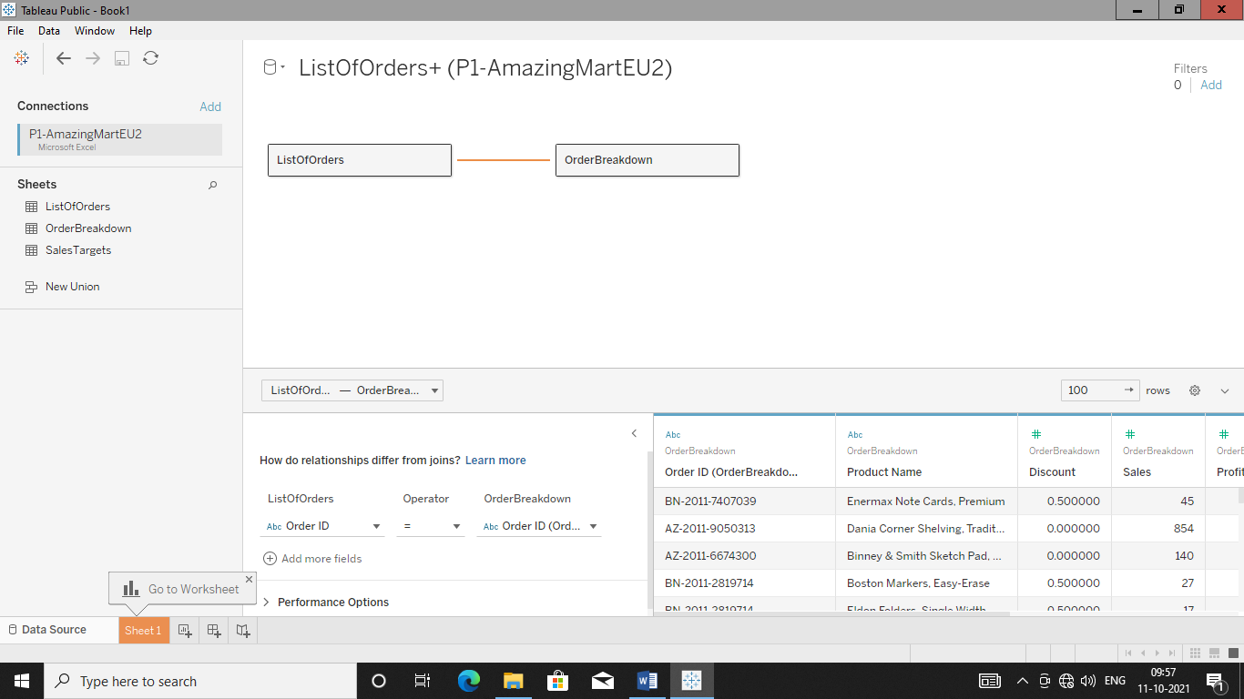

Now if we go to sheet 1 than hierarchy is created own by tableau as shown below

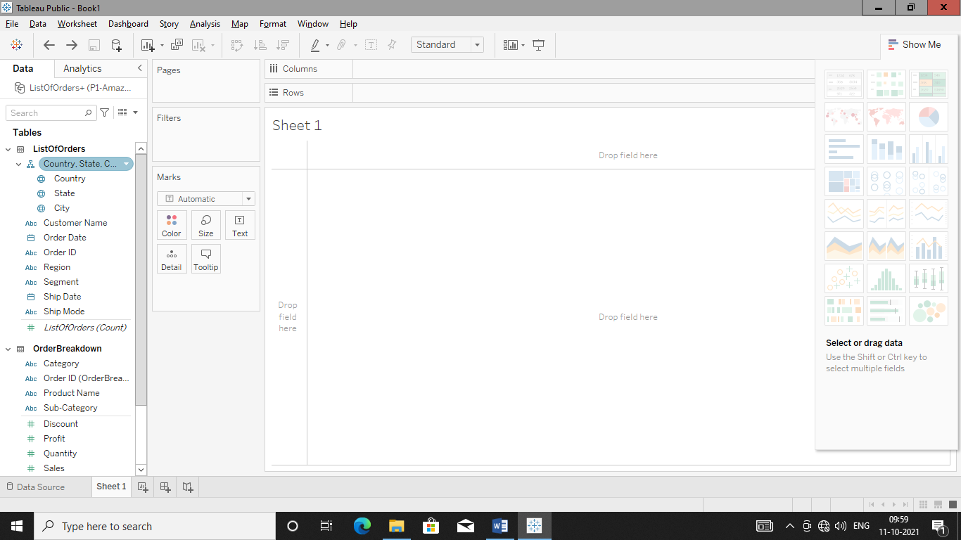So just remove that hierarchy by right clicking it and than create own hierarchy manually.

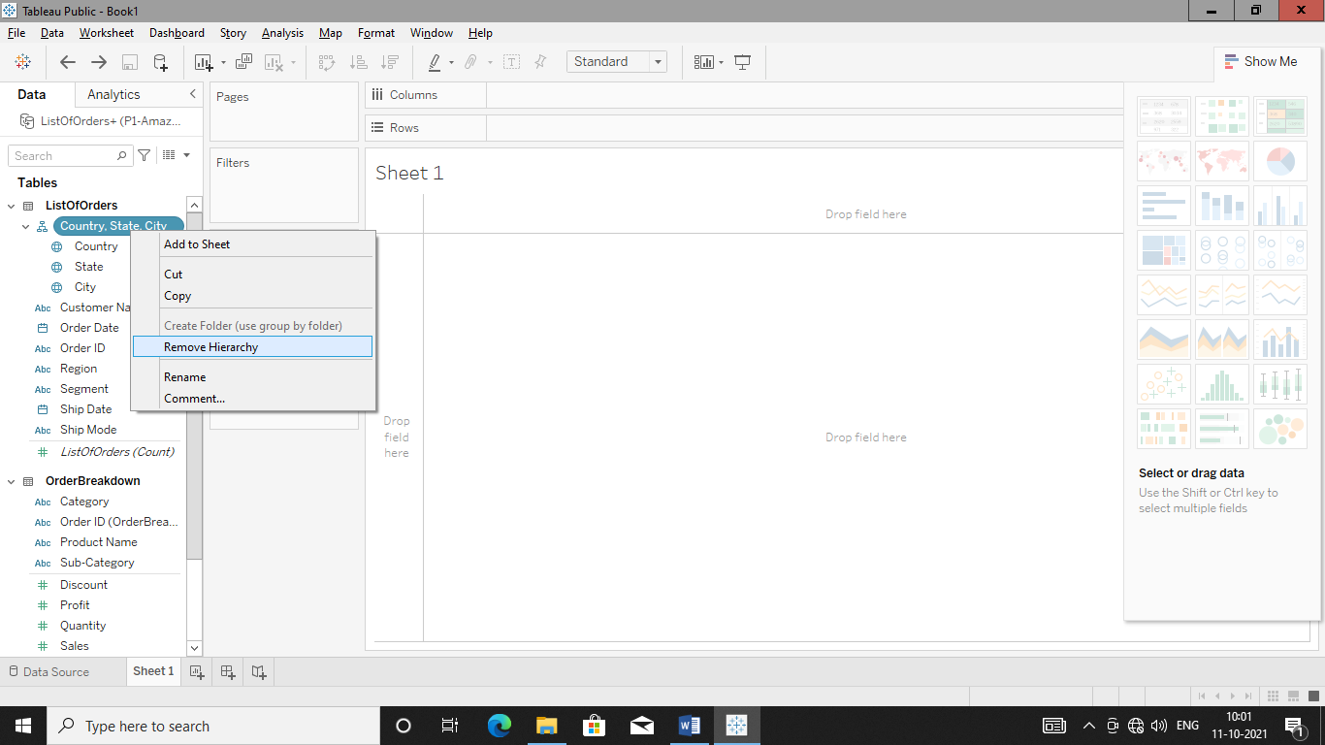

Just Drag and drop two dimensions than tableau will automatically ask to give new name to that hierarchy.

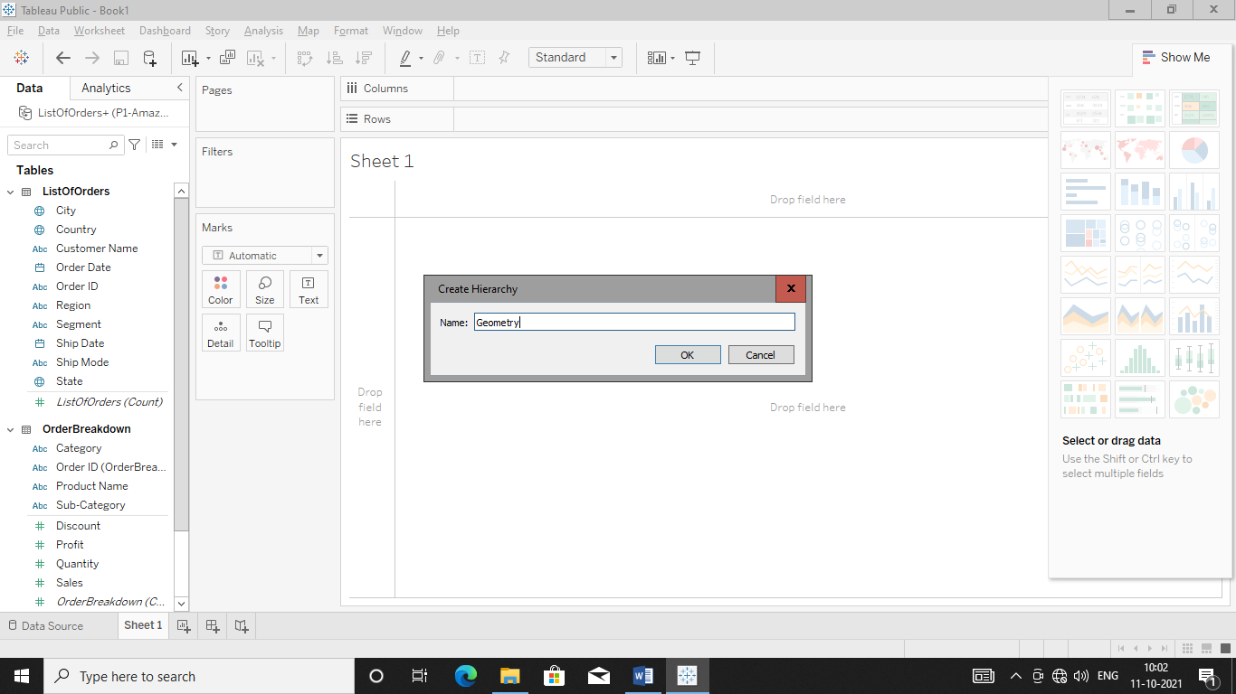

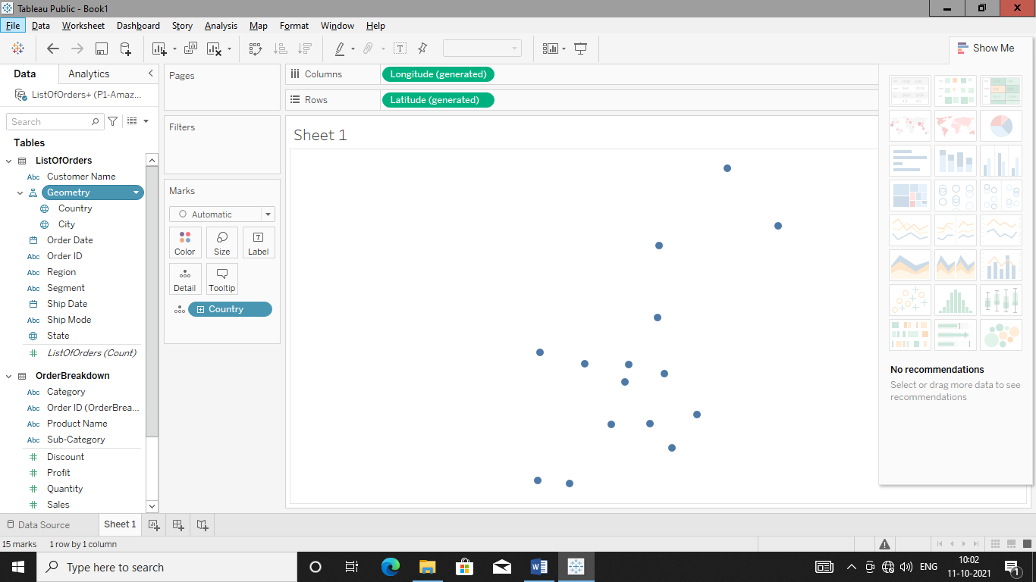

Drag and drop state between country and city to complete a hierarchy

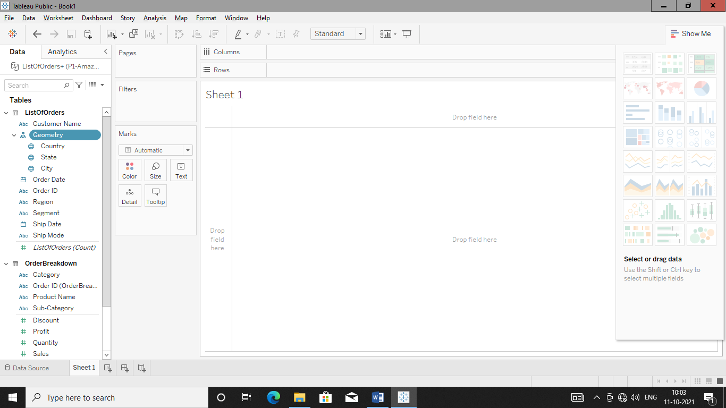

Plot country map by double clicking it

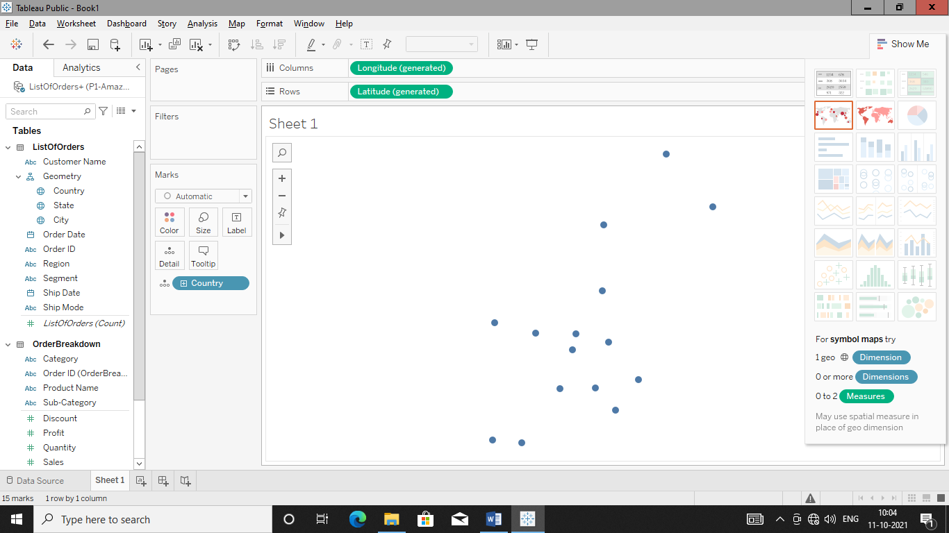

As well as plot state also

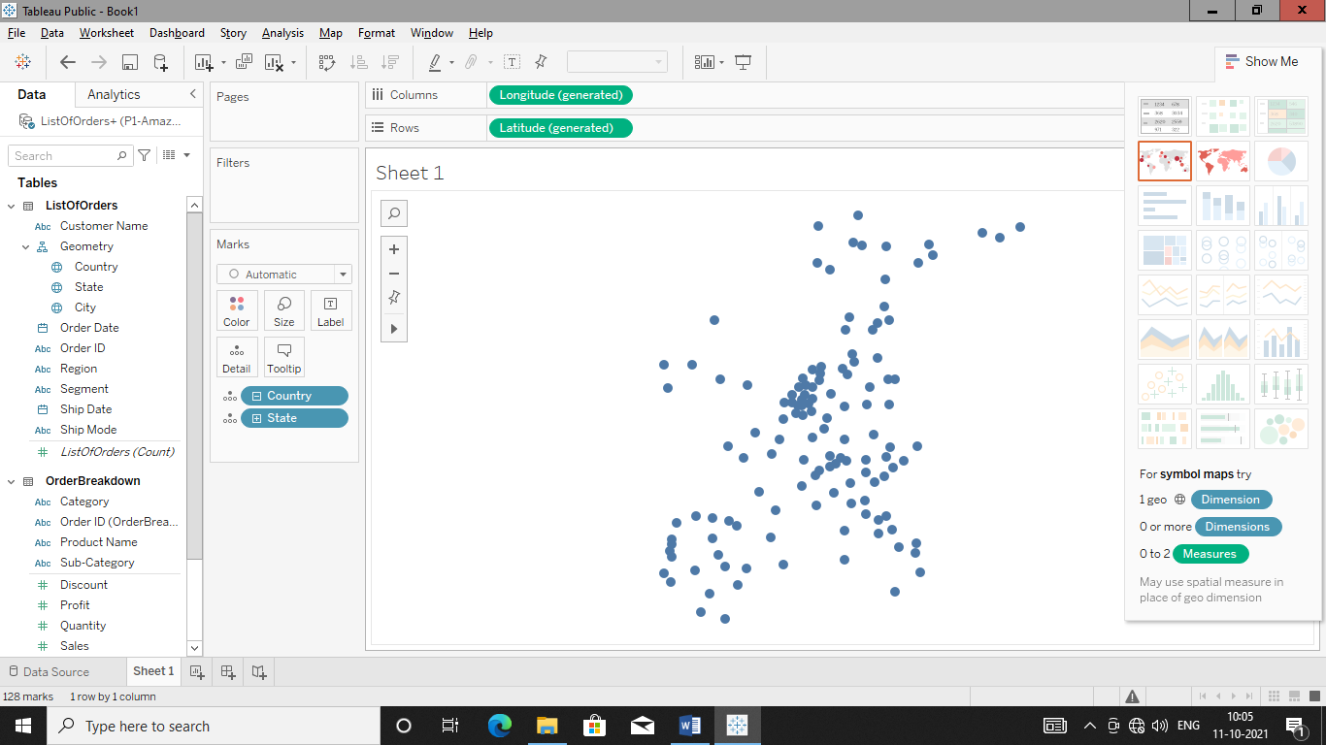

Apply color filter to country.

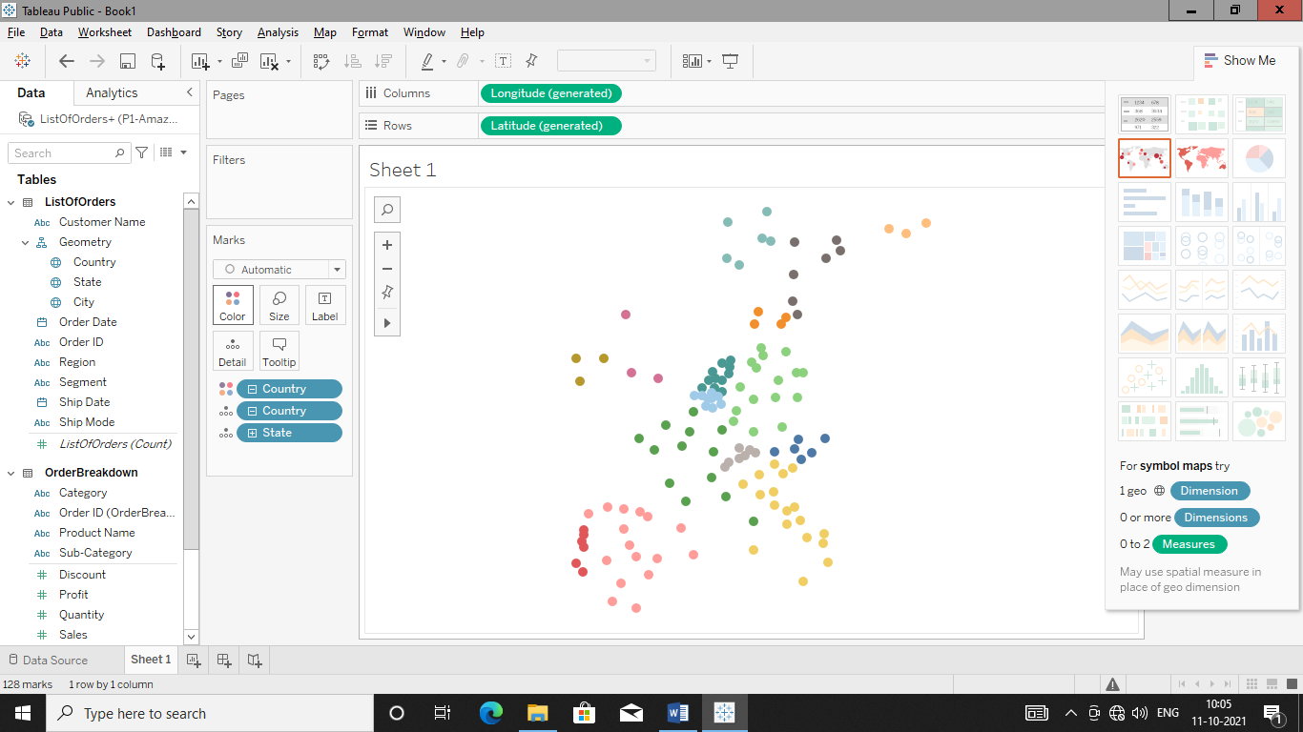

Add state name as labels.

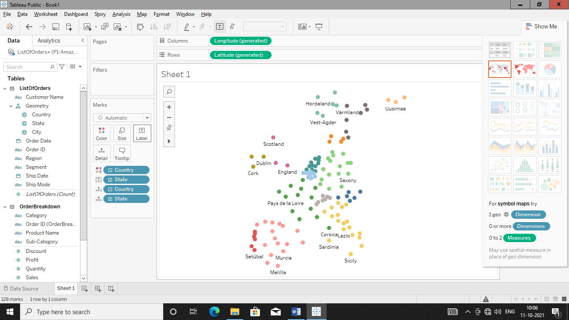

**Q. Plot order details of year 2011(do create filter with slider)**

Add order date to filter for getting this information

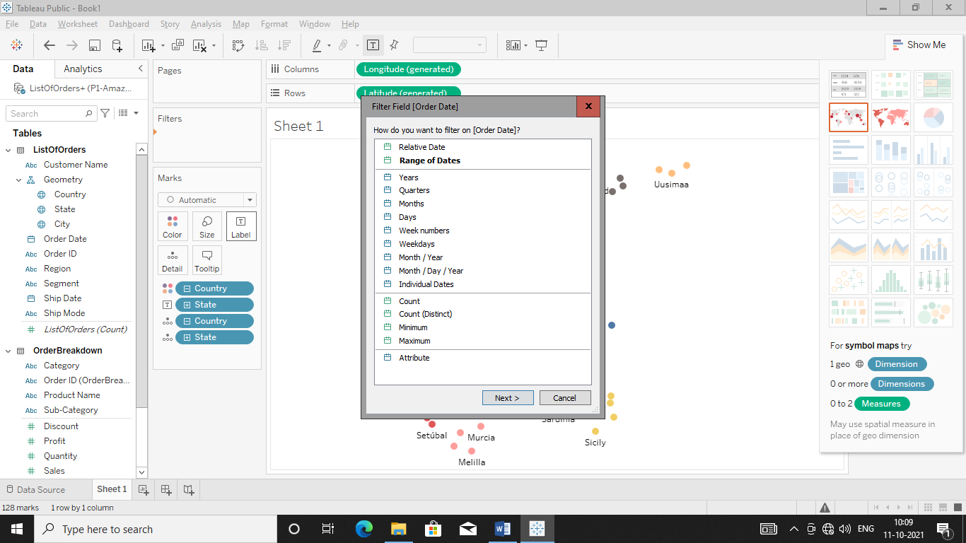Select Years as we want of year 2011

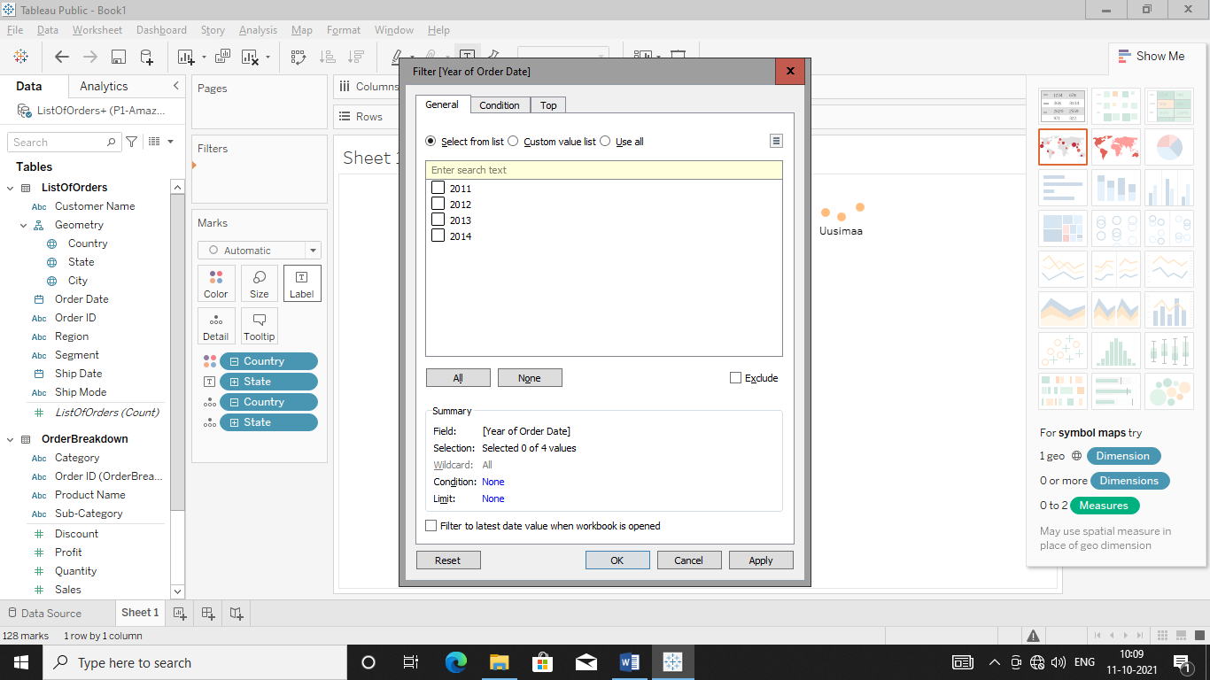

Select 2011 in above diagram

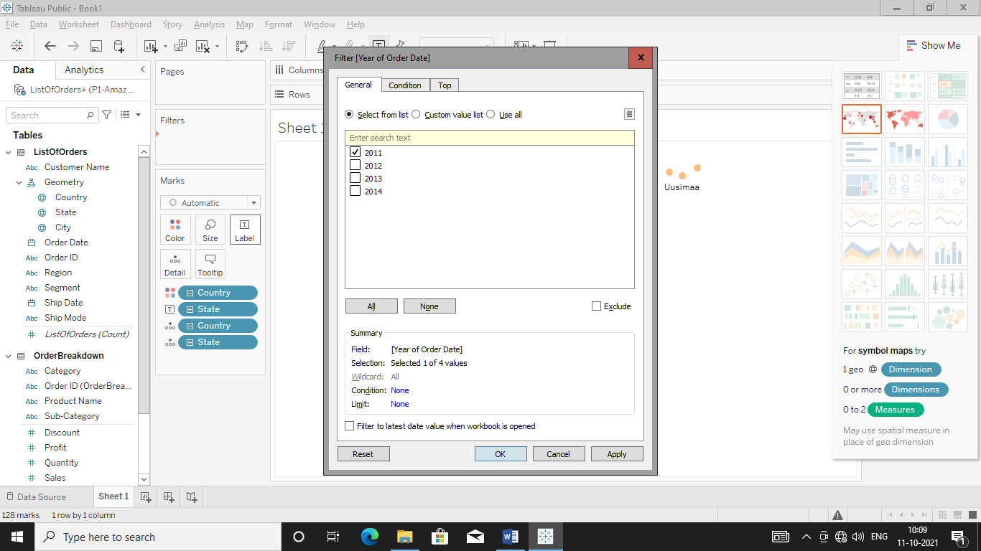Hit Apply in order to get output

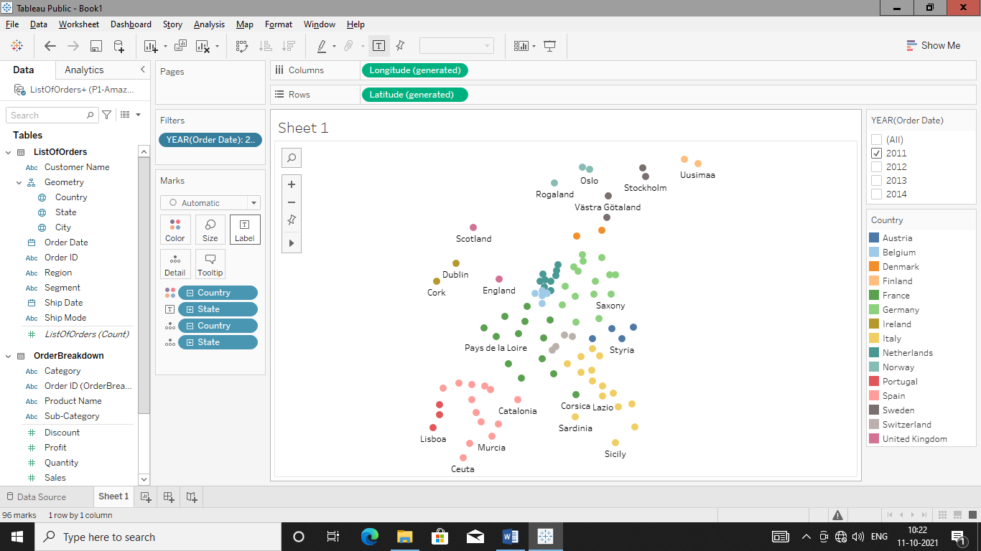  
Remove all option from filter box

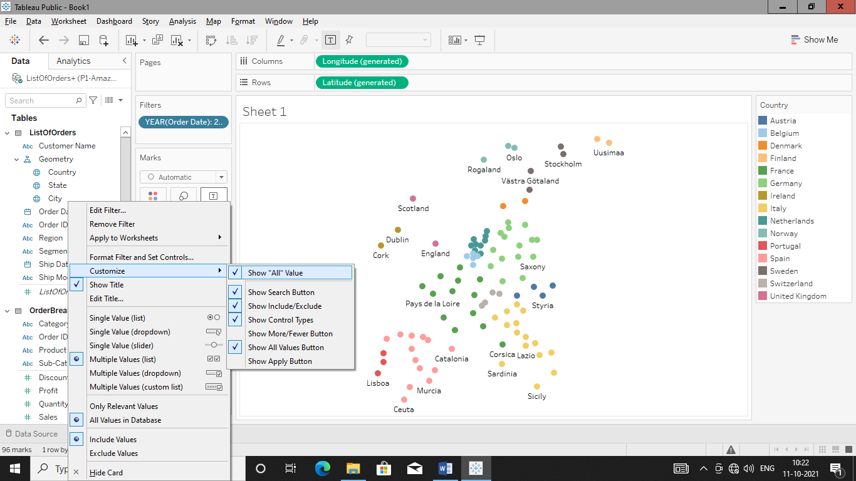

Hit Show All Value to remove it

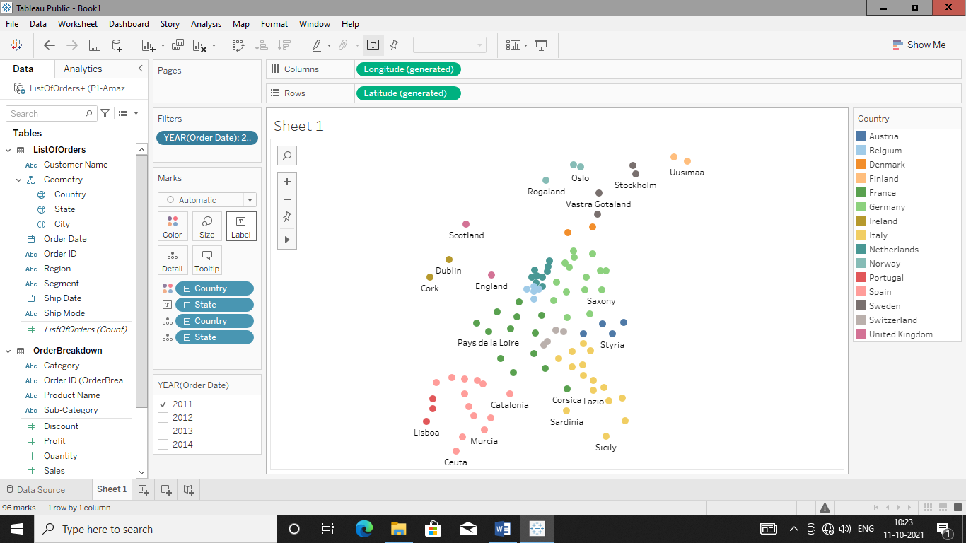

Make Filter as Slider

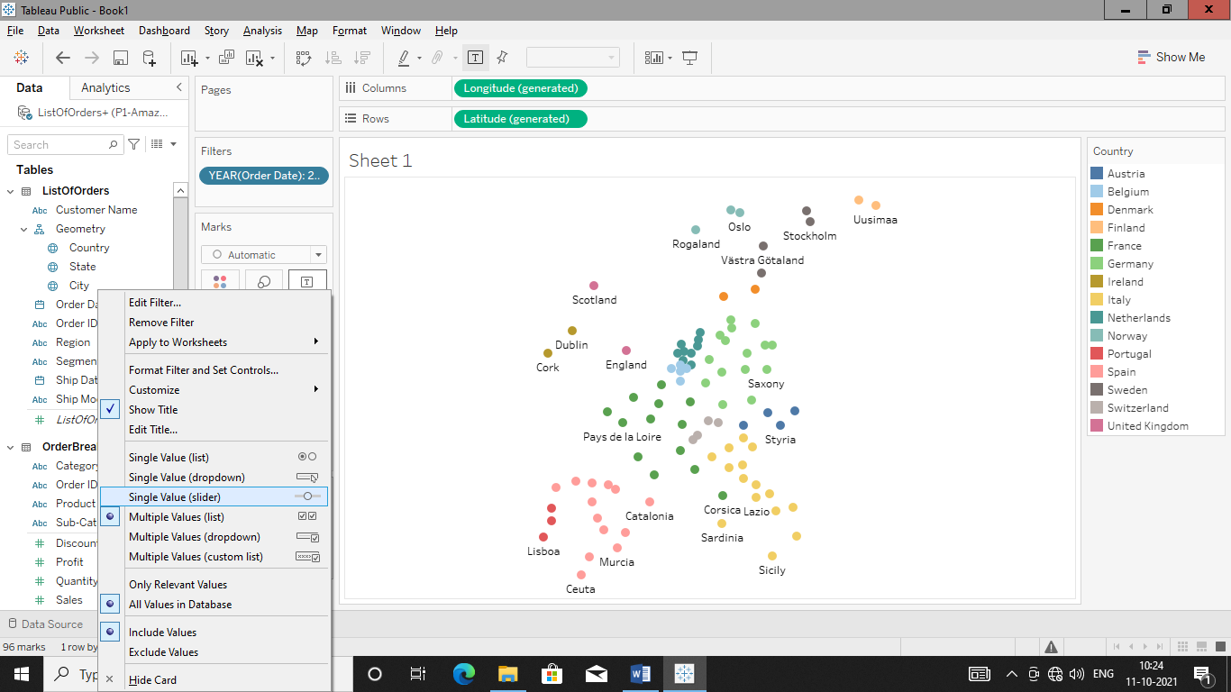

Hit single valued (Slider) to transform filter box in to slider

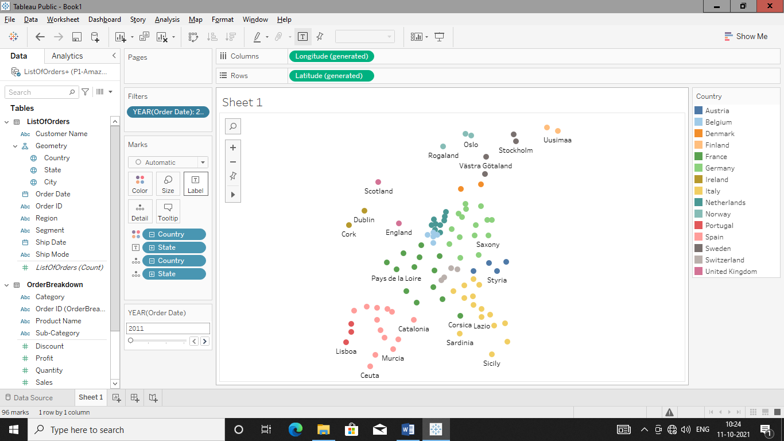

Add Sales to Size box to manipulate map bubble size according to state

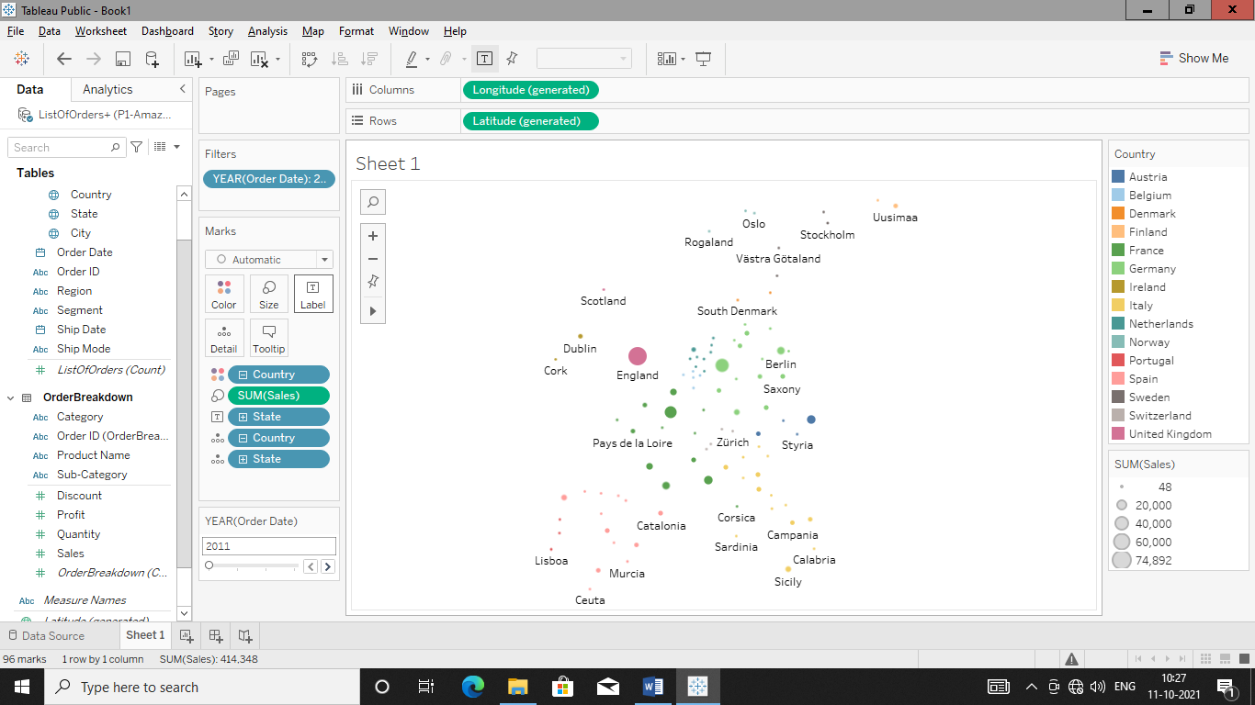

Create calculated field profit margin by right clicking profit as shown above

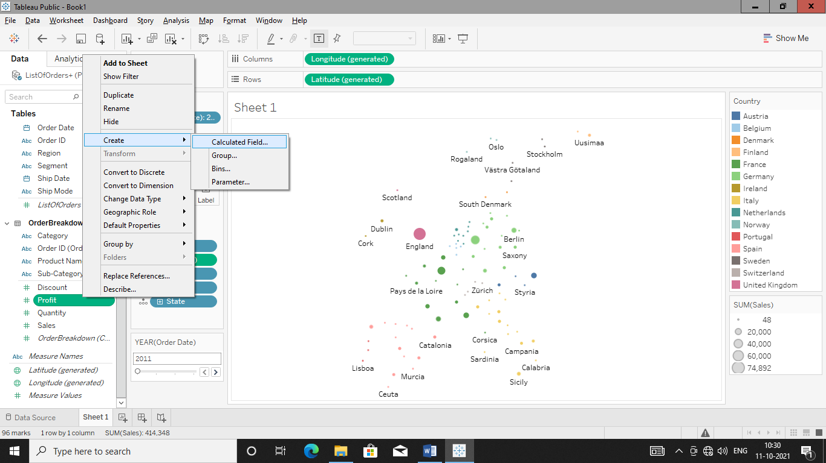

Calculate profit margin and make calculated field

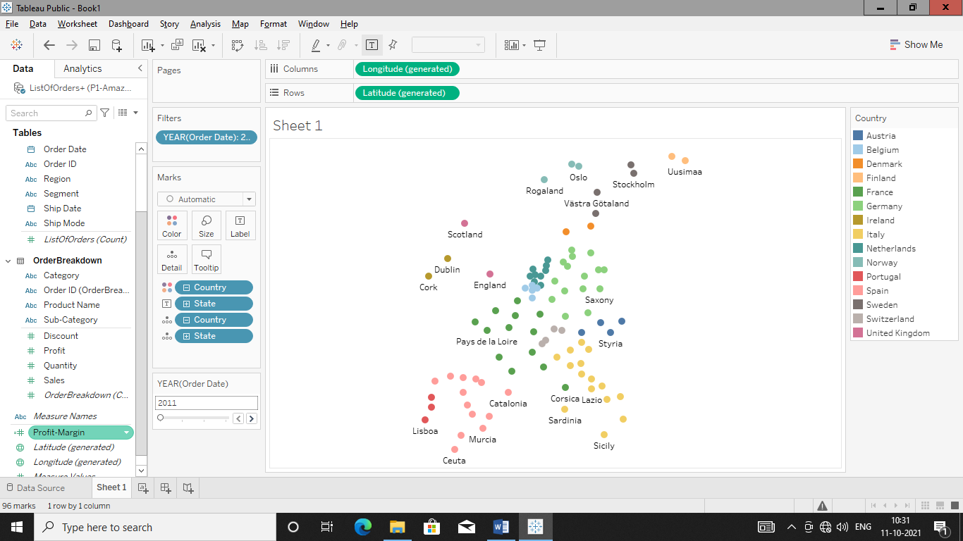

Add profit margin to size tab to get map

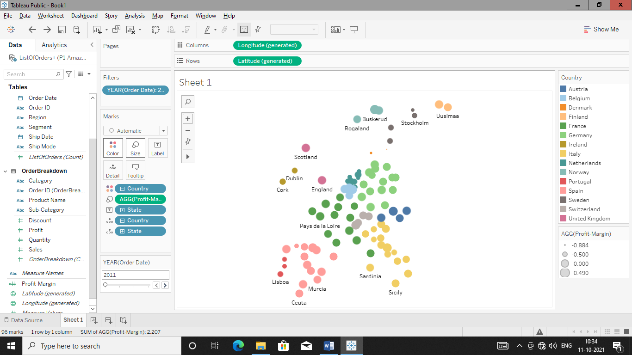

Add profit margin to colour tab to get details of profit margin state wise in map

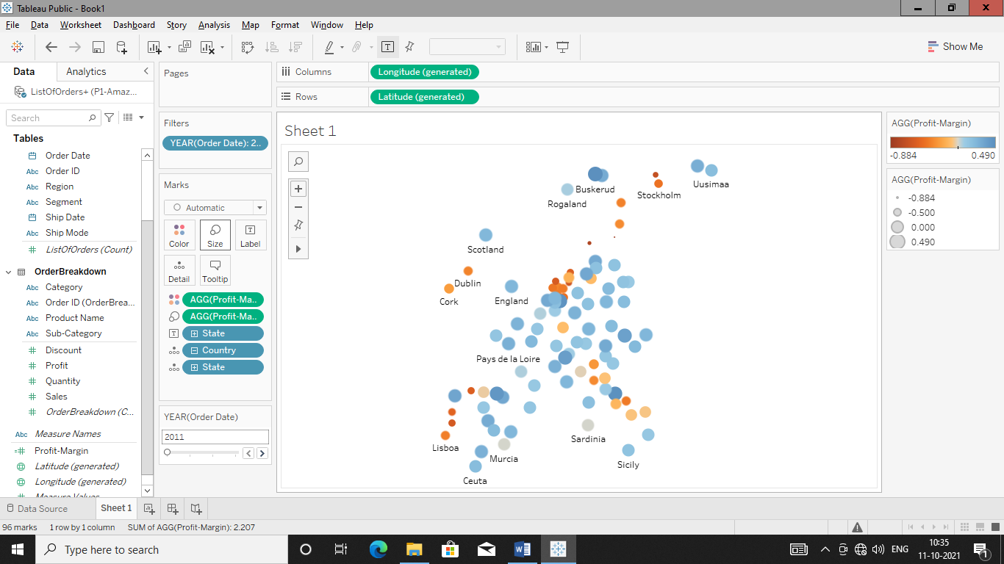

Change color filter to blue-red

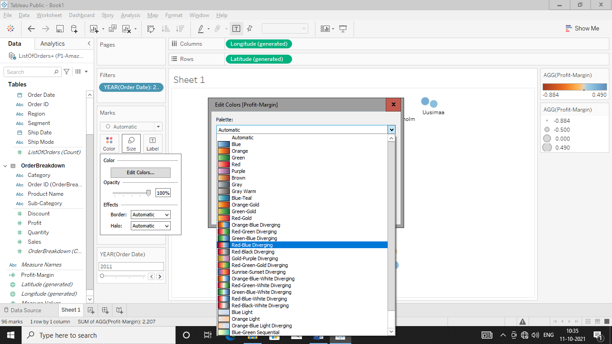

Click on advance

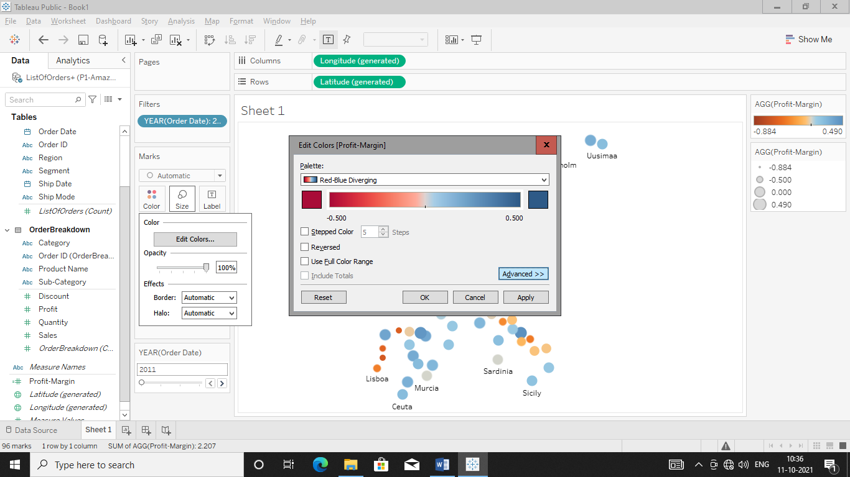

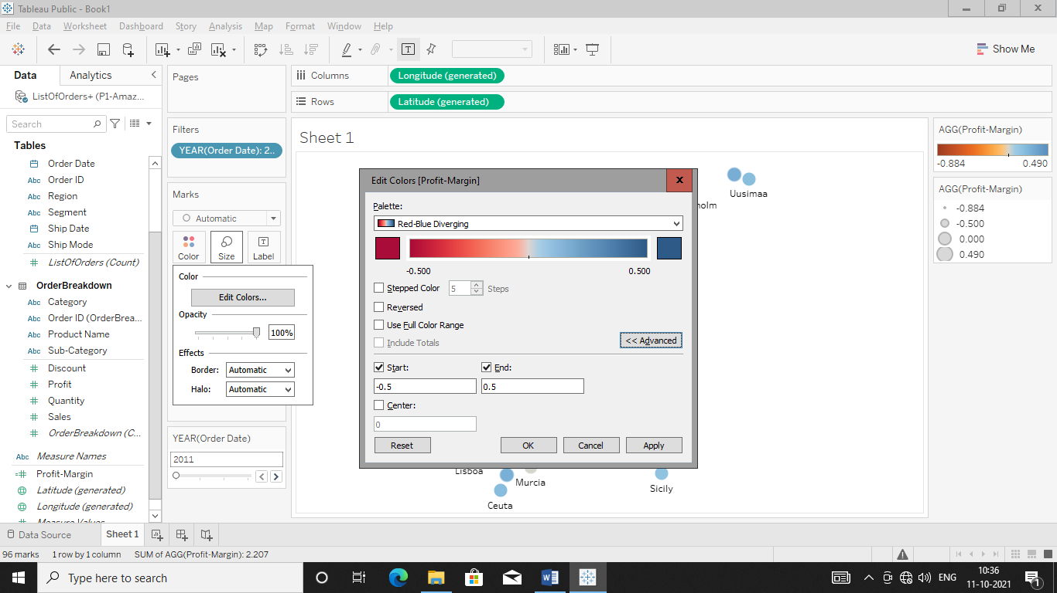

Change Start to -0.5 and End to 0.5 and hit Apply and cliuck ok to get respective output

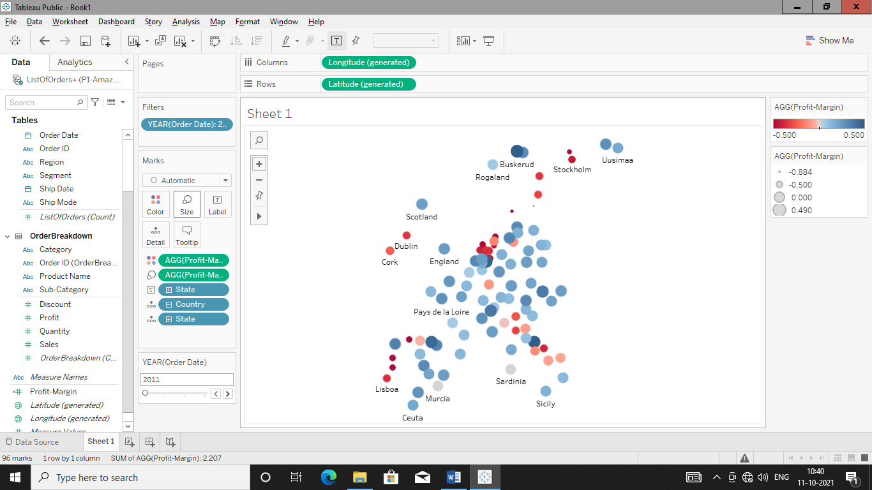

Remove profit margin from size to get clear map

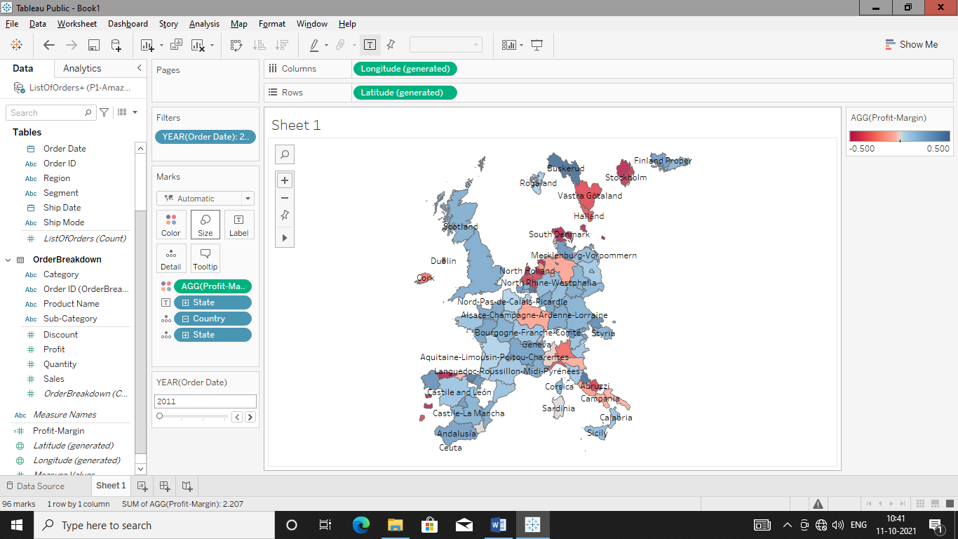

Create Scatter Plot between profit and Sales

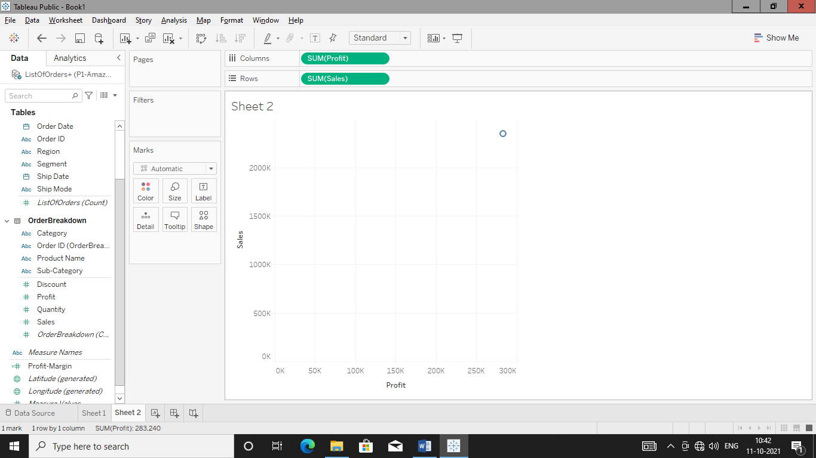

Add Customer name to details as we want scatter diagram of profit & sale for specific customers.

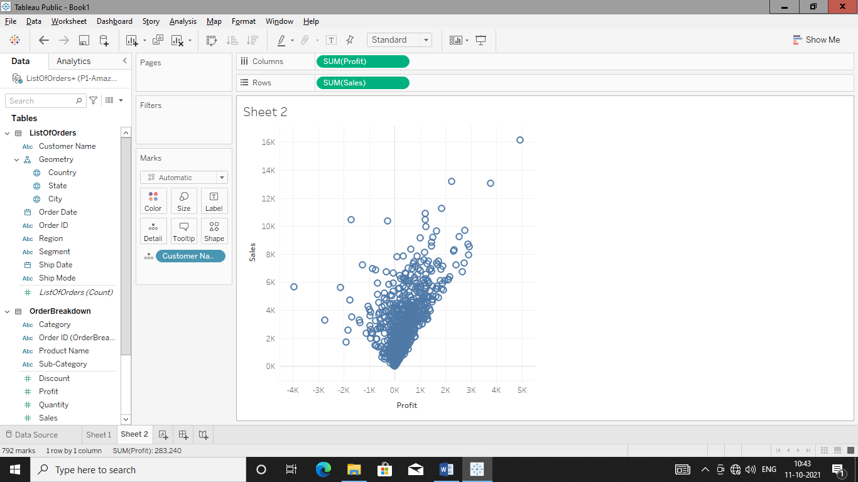

Add Country to Color to get scatter diagram of profit-sales of customers with country colours

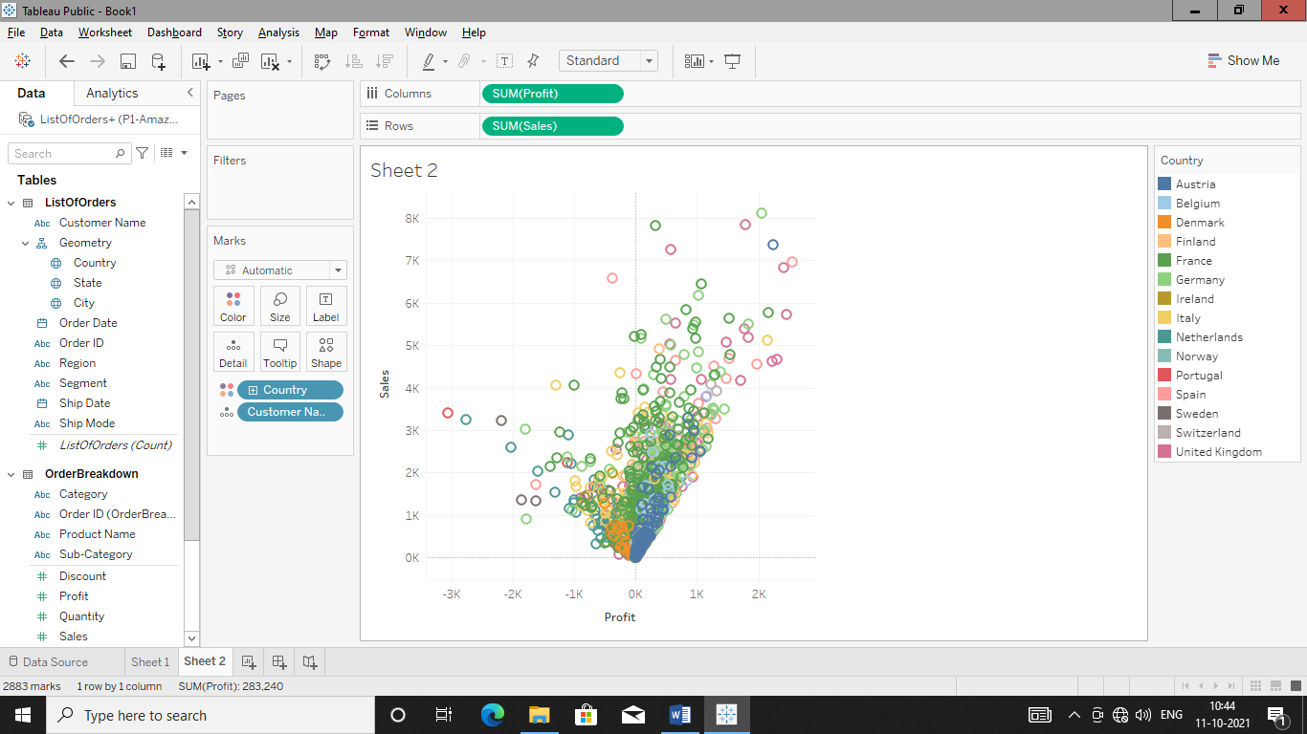

Add profit margin to colour tab to get scatter diagram of specific customer with colour code

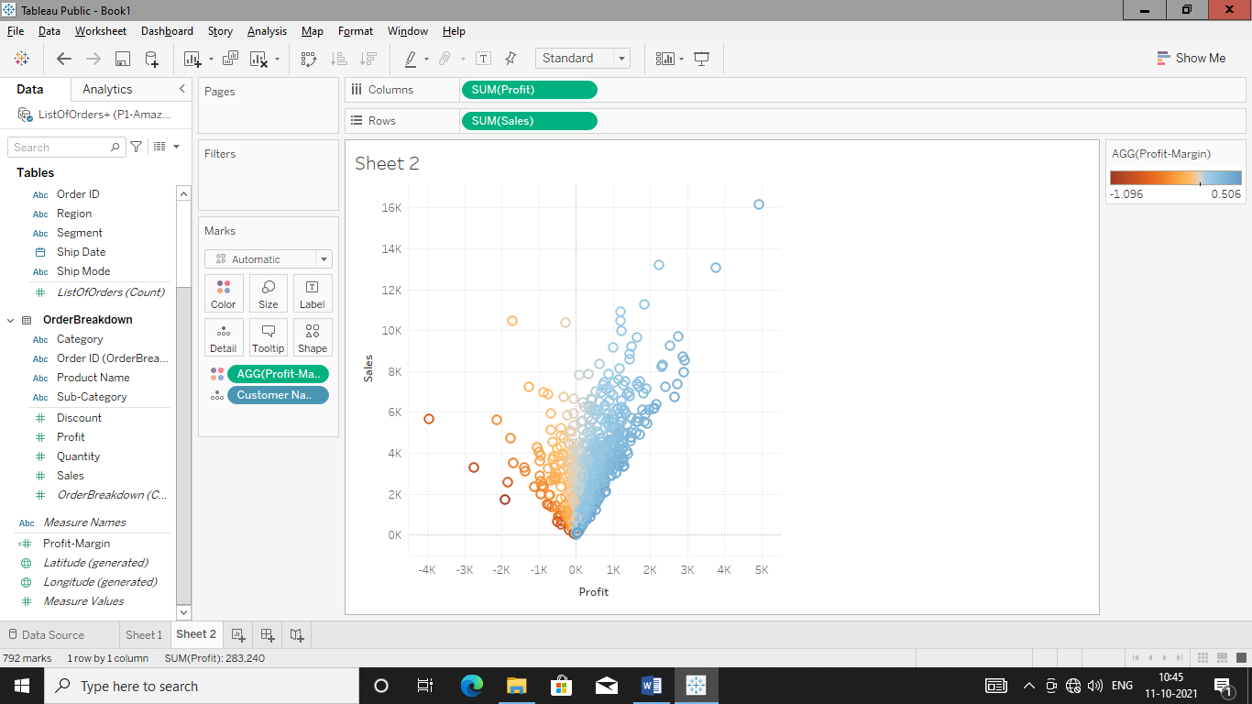

Add Order date to filter tab and filter scatter diagram year wise in order to get graph year wise with customer name and profit margin colour.

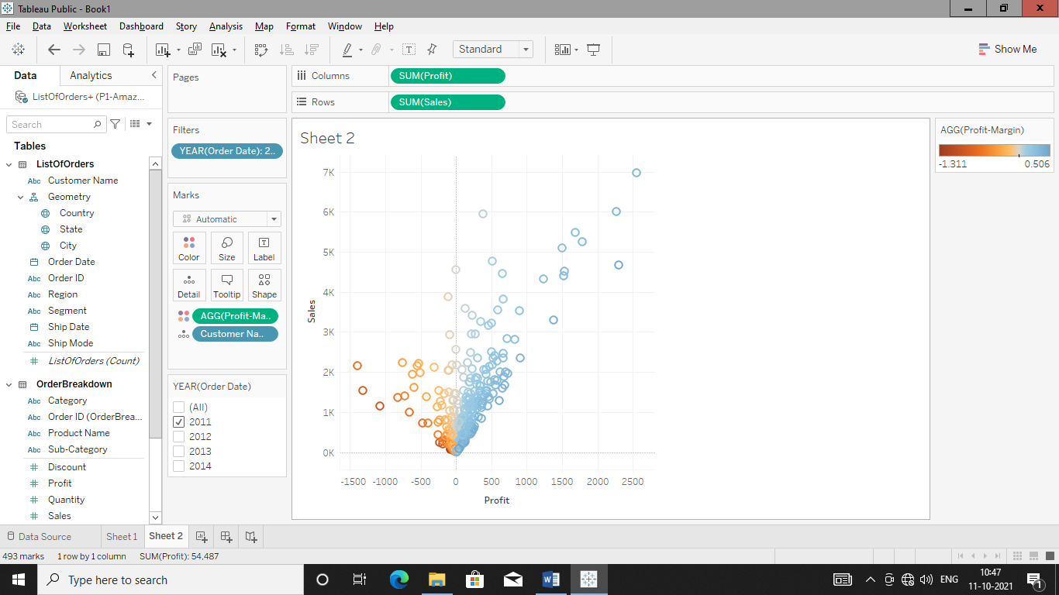

Create dashboard and drop sheets

